

Exploration and Analysis of Indian Elections of 2014 using Sentiment Analysis and Classification Algorithms

MSc Research Project

MSc in Data Analytics

Tanay Kasar

Student ID: X17156700

School of Computing

National College of Ireland

Supervisor: Dr. Yalemisew Abgaz

National College of Ireland

MSc Project Submission Sheet

School of Computing
Student Name: | Tanay Kasar
Student ID: | 17156700
Programme: | Msc. In Data Analytics | Year: | January 2018.
Module: | Research Project
Supervisor: | Dr. Yalemisew Abgaz
Submission Due Date: | 18th April,2019
Project Title: | Exploration and Analysis of Indian Elections of 2014 using Sentiment Analysis and Classification Algorithms
Word Count: | 6632 Page Count: 24

I hereby certify that the information contained in this (my submission) is information pertaining to research I conducted for this project. All information other than my own contribution will be fully referenced and listed in the relevant bibliography section at the rear of the project.
ALL internet material must be referenced in the bibliography section. Students are required to use the Referencing Standard specified in the report template. To use other author's written or electronic work is illegal (plagiarism) and may result in disciplinary action.
Signature: | ………………………………………………………………………………………………………………
Date: | ………………………………………………………………………………………………………………

PLEASE READ THE FOLLOWING INSTRUCTIONS AND CHECKLIST

Attach a completed copy of this sheet to each project (including multiple copies) | □
Attach a Moodle submission receipt of the online project submission, to each project (including multiple copies). | □
You must ensure that you retain a HARD COPY of the project, both for your own reference and in case a project is lost or mislaid. It is not sufficient to keep a copy on computer. | □

Assignments that are submitted to the Programme Coordinator Office must be placed into the assignment box located outside the office.

Office Use Only
Signature:
Date:
Penalty Applied (if applicable):

Exploration and Analysis of Indian Elections of 2014 using Sentiment Analysis and Classification Algorithms

Tanay Kasar

X17156700

Abstract
India is a vast country, with the largest democracy and a large population. In the year of 2014, India conducted the Lok Sabha elections. There are 543 seats in the parliament for which the elections were held. The election of India’s Prime Minister is the most significant part of the election. These elections are conducted in a period of 5 years. Indian government spends 5 billion dollars on conducting these elections. The election process was divided into 9 phases. Each phase was executed sequentially as they were numbered. In 2014 election India witnessed an exponential rise in the number of new voters. Political leaders and their parties made the use of social media platforms for their campaigning. Twitter and Facebook were used the most to spread their agenda. The number of users on Twitter has increased in the recent times. These users on twitter post their views and opinions regarding the political leaders and their parties to show support or opposition. Thus a decision of using these tweets as source of information to analyse and predict the Indian Elections was made. Tweets posted from later half of 2013 to May 2014 were extracted.
A dataset was formed after combining all of these tweets. This data was used to derive insights and analyse the scenario. The information obtained from the data reflected that the users were influenced by activities of the politicians. In the past there were certain questions raised on this approach of relying on the tweets as a source. But in our research, a new approach of classification is proposed. The classification of the tweets was done on their orientation towards a political party or a leader. Models like naïve bayes, random forest, XGboost and RNN-LSTM were trained. After the analysis of the data it was found that ‘Bharatiya Janta Party’ and their Narendra Modi were more famous in the elections. These tweets were classified as tweets in favour and tweets which are against to a front
This classification solves the issues that were raised in the past. The outcomes of this research can be used for analysing the election of 2019, which are on-going in India.

Introduction

India is considered as the world’s largest democracy. It is also one of the most populated country on the globe. In the recent year of 2014, India held its elections for Lok Sabha. Lok Sabha consists of all the candidates of the party which has won the elections. Lok Sabha plays a vital role in governing the country. The Prime Minister of India is appointed from the party which has won the elections. This makes the elections very important. These elections are conducted in a period of five years. That means the next elections will be held in 2019. There are 543 constituencies in India for which the election is held. In order to secure majority a party must win 272 seats at least. If a party doesn’t achieve 272 seats by itself then it can achieve that number with co-alliance with other party. There is a committee drafted for conducting the election, ‘Election Commission of India (ECI)’. The commission has recognized 814.5 million voters in the year of 2014. 713 million voters were registered for the year 2009. There is a significant increase in the number of voters.
India has a huge budget allotted for conducting its elections. It has 0.9 million polling stations. There are 1.73 million units for controlling and 1.87 ballots. The 2014 election is divided in 9 phases from 7th of April 2014 till 12th May 2014. These 9 phases were carried within this timeline for all the constituencies in India. The 5th phase was considered as a largest phase which includes 122 constituencies. 1st phase included only 6 constituencies, making it the smallest of all the phases. According to ECI, 1,616 parties had participated for the election of 2014. These parties include the national parties, state parties and others as unrecognized parties. ‘Indian National Congress (INC)’, ‘Bhartiya Janta Party (BJP)’ and the ‘Aam Aadmi Party (AAP)’ were among the most recognized parties for this election. It was observed that these parties had secured large number of votes in the constituencies. There are also some other state parties which gained a significant support from the population. From BJP Narendra Modi, Rahul Gandhi from INC, Arvind Kejriwal in AAP were among the strong contestants for the Prime Ministerial elections. These mentioned contestants were the most influential candidates and thus each of them was on the fore-front of their respective parties. The image displayed below, represents the 9 phases of elections held across the whole country

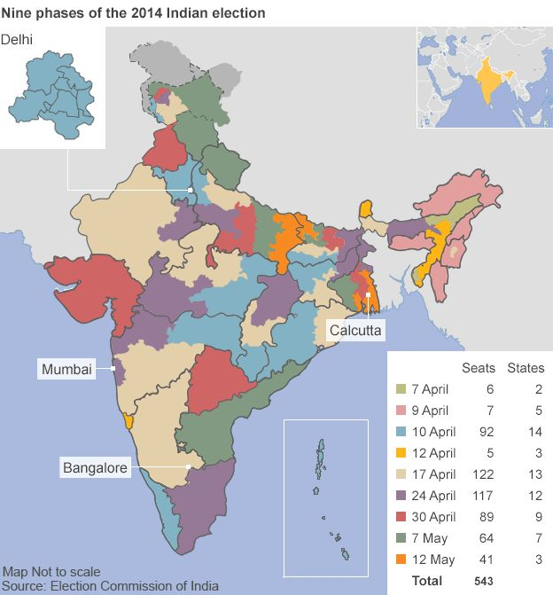
Figure 1: The 9 Phases of the Election of 2014

Role of Social Media in Election

The recent years have experienced a tremendous increase in the use of social media. Social media platforms like Twitter, Facebook, Instagram and many more have gained millions of users in these years. India has the 2nd most number of people using these social media platforms. People use these platforms to share their views on the current political affairs. This raises awareness on a large scale, since their views are read by millions of other users. With the trend of social media, the political parties have launched their campaign of these social media fronts. This enables them to reach out to the population. Political Leaders have their official accounts on these social sites. Thus the leaders can get in touch with common people in a view of answering their queries with a hope of securing their vote.

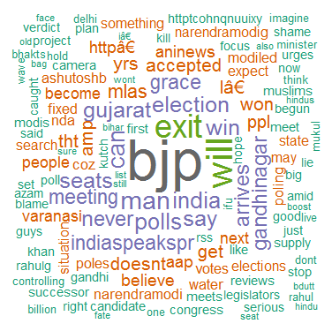
Figure 2: Word cloud image of elections of 2014

In the above image we can observe the words which were most frequently used to define a scenario. The political parties have their official pages on Twitter and Facebook to promote their agenda and share their recent progress. Applications like Hangout and Google+ came into use by these political parties to host meetings with group of people. Posters of the leaders with their agenda was broadcasted on Facebook and Instagram. Uploading of videos on Youtube, as a part of the campaign.

Motivation for Research

As discussed earlier the number of users on twitters has increased in the past years. It has become a medium for people for sharing their views and their concerns. Twitter is full of messages by people, which post their messages on the site. Twitter has become has great source of data since it contains tweets which cover a number of activities going on in the world. India’s Lok Sabha election is among the biggest event in 5 years. There is a lot of discussion on twitter before and after the elections. This means that it provides us with huge amount of data which can be used to understand the election process. This data can be used to find the overall influence of these political parties along with the support shown by the people. Patterns can be obtained from this data which can be further used to understand the elections in 2019.

Research Aim

The aim is to analyse the data obtained from Twitter to derive insights and understand the patterns observed from the people’s views. We aim to find the popularity of leaders in the this election campaign of 2014. Similarly to find the number of users on twitter which followed the hashtags on twitter. We also aim to target the trending hashtags which were most trending during this period of time. To classify the tweets according to the political party or leader for which it was meant for. The tweets will be classified on the basis of negative and positive response offered by the users regarding the political parties and leaders. As mentioned earlier BJP , AAP and INC are the parties which grabbed a lot of attention of social media. The positive views recorded on twitter will be classified as FavourBJP, FavourAAP, FavourINC. In similar way negative tweets will be classified as AgainstBJP, AgainstAAP, AgainstINC. Since there is a large flow on data on twitter, a system is needed which will provide and assist in analysis of this data.

- To obtain insights and inferences from the data collected from twitter
- To implement a classification model on the data which will be used to classify the sentiments of the users regarding the elections.

Related Work

In the recent years the usage of social media sites like Twitter and Facebook has increased exponentially. They have become a new medium of communication between billions of people across the globe. There has been number of researches implemented in which the authors used twitter as a source to gather data on a particular topic. The discussions on twitter provides us with the views and opinions of the people regarding a specific. In this section we will discuss the techniques and approach followed by the authors to carry out sentiment analysis on twitter.

Research using Twitter

In this section we will focus on the researches which made the use of twitter as the source of data. Pak et. al. [1] who analysed 30000 tweets which were based on the emotions expressed by the users. These tweets were then further classified into positive emotions and negative emotions, along with tweets which don’t reflect any emotion. The aim of their research was to develop a classifier system which will operate on a microblogging level. Where as Agarwal et. al. [2] collected large number of tweets to classify them into sentiments. For classifying the text data in the tweets, they made the use of unigram models. In our research we aim to classify the tweets using models like random forest. In this research the authors had targeted the acronyms which represent the sentiment of the tweet. In general twitter has been used for sentiment analysis which refers to extensive text mining. Languages other than English have been configured to extract vital information from them as mentioned by Nakov et. al. [3].
Mood detection was a new concept proposed by Mao et. al. [4]. Tweets were classified by the sentiments expressed by the tweets. They were classified in anger, joy, rage, sadness. This concept proved to be vital in understanding the response of people towards a particular topic. The use of machine learning models has further boosted the applications of sentiment analysis as demonstrated by Wilson et. al. [5]. The author has divided the process into two stages. 1st stage targets the words which convey the opinion of the text. The second stage uses these targeted words to decode the information. This approach takes less time compared to other conventional methods. Some researchers didn’t trust these techniques. They carried their own research to find out whether there techniques are applicable. Proposal by Metaxas et. al. [15] stated that sentiment analysis can be useful but with consideration of factors like population and their orientation.

Research on Elections

There was a research introduced which was based on the U.S Presidential elections by Wang et. al. [6]. In this research the author aims to provide a real time system which will provide with statistics of the election. These statistics were obtained by extracting the information from the tweets. The system classifies the tweets according to the polarity observed. It proved to be useful for analysts to understand the trend observed and also to predict the outcomes. It provides insights in a simplified and organised approach. In the U.S presidential elections there were only 2 final candidates. But in our case there are 3 candidates, thus our research involves more classification process since we aim to obtain positive and negative sentiments for the 3 candidates. People were employed for the campaigning of political fronts on twitter. It is considered that President Obama won the elections because of his strong campaigning on twitter. The research proposed by Tumasjan et. al. [7] covers an extensive study on President Obama’s campaigning. For our research we will focus on the campaigning of AAP, BJP and INC candidates.
In a research proposed by Chung et. al. [8], it focuses on examining the performance of sentiment analysis. Their aim was to find whether these techniques are reliable for predicting the election outcomes. The author has referred to number of researches on the particular topic. In conclusion author mentions, data obtained after text mining should be pre-processed. Number of Classification models should be implemented on this data to compare the result obtained from each model. Research proposed by Bermingham et. al. [9] carries sentiment analysis on the Irish elections. The author uses machine learning models for classification. In conclusion the author mentions that in order to achieve high accuracy in prediction the number of tweets matters. The chances of winning for a candidate depends on number of tweets received by users. The predictions won’t be reliable if more number of tweets are not obtained. There was a research on elections in Singapore by Skoric et. al. [10]. The results obtained after implementation were reliable but the accuracy was lower than that of previously discussed researches.
Political preference was determined by finding out which accounts were followed by the users. This particular approach was proposed by Golbeck et. al. [11]. This research states that the leader having most number of followers has the greater chance of winning the election. In some of the researches referred there was doubt raised about the prediction by using tweets. This doubt was proposed by Castillo et. al. [12]. Followed by Mustafaraj et. al. [13] raised a question on the reliability on the tweets posted by the users. The solution for these queries can be solved by adding more classifiers to the search. There are a few attempts made to predict the outcomes of the elections. These researches were proposed on U.S elections. In one the researches by Conover et. al. [14]. The efficiency obtained was 95 %, this was achieved by using semantic analysis.

Classification Algorithms

In this section, the classification models that were trained on the data are explained. For the classification task 3 models were selected. They are Random Forest, XGBoost and LSTM Random Forest is considered as one of the most accurate model. Its preferred from classification for large data sets. It can also be used for regression. A research proposed Cootes et. al. [18] states that random forest models doesn’t overfit due the use of multiple decision trees. In a research proposed by Shah et. al. [19] the disadvantages of random forest model is discussed. The paper states that random forest models have high complexity and it takes more time in computation. Gradient Boosting algorithm is another ensemble machine learning model. It is alsp preferred for classification and prediction tasks. As described in a research by Chen et. al. [20] XGBoost builds all its trees simultaneously. This makes it to correct any errors occurred in one step quickly. But processing time exceeds than that for random forest model. ‘Long Short-term Memory (LSTM)’ is a type of neural network which is termed as Recurrent Networks. It is used for text segmentation for natural language processing (NLP). Models can be trained on text data using LSTM. It can generate its own sample text which relevant to the extracted text. It is also used for translation tasks as proposed by Fan et. al. [21]. From a research proposed by McCallum et. al. [22] states that naïve bayes model is simple to implement. It uses less data for training. It can be used for predictions where probabilities are involved.

Contribution of the Research

This sub-section highlights the work done in this proposed research after referring the above explained researches

- Classification of the political orientation is proposed based on the tweets posted by Indian users. As in the elections there were number of contestants in the elections, thus the task becomes difficult.

- Analysis on tweets in favour and also on the tweets which were against to a particular party. This classification will prove to be vital for understanding the scenario and also will answer the concerns raised on this particular approach.

- From the results it is observed that the party ‘BJP’ has more support from people. While Narendra Modi from BJP was the most popular candidate for the Prime-Minister’s election.

Research Methodology

In this section the methodology followed to implement the proposed research is discussed. For this research KDD methodology was selected. KDD stand for ‘Knowledge Discovery in Databases’.

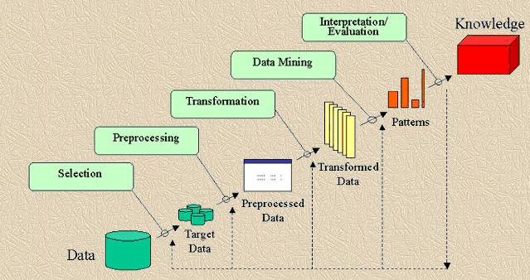
Figure 3: KDD Methodology

From the image displayed above we can observe that the KDD-methodology is divided into multiple steps. It was selected because this research deals with acquiring knowledge from the twitter. The KDD methodology aim to extract information from a database. Each of the steps are arranged in specific order. The implementation of this follows this methodology. In this section we will discuss each of this steps and their relevance to the project

- Understanding the data:

In this step the structure of the data needs to be understood. The aim of the research should be taken into consideration. To check the suitability of data for the task. To check if the proposed solution is solving the issue sufficiently. After getting the clarity of the data, the target variable must identified. In our case the tweets on the twitter is our data and getting the required tweets is our target.

- Studying the targeted data:

The tweets containing the information related to elections of 2014 is our data. The tweets which favor and oppose any political party or leader needs to be extracted. These tweets are targeted by using specific words which target the tweets. The tweets were extracted and stored in the system in JSON format. Later these files were converted into .csv format.

- Data Processing and Transformation:

Pre-Processing is one the most important steps in any implementation. The cleaning of data starts with removal of hash-tags and unwanted character from the data. On twitter when a user posts his tweets, there may be number of grammatical, and punctuational mistakes in the tweets. In a view of acquiring a clean data, the above mentioned issues should be solved. In the later stages of the report these steps have been described in brief.

- Implementation of Classification Models:

After the data is been cleaned and transformed, models can be implemented. In our research we have implemented a number of models like Naïve bayes, XGBoost, Random Forest and LSTM. These models were trained on the final form of the data. The model with the best accuracy will be selected as the bench-mark model.

- Interpretation and evaluation:

After testing the models, their accuracy was deduced. The output of the model is interpreted to formulate over final outcome. In our case, the output show the support and opposition acquired by the political fronts.

Design Specification

In this section the techniques and frameworks used in the building of this project are described. The entire design specification is divided in two parts. The Anaconda Navigator was used as platform for computing. The Jupyter notebook in the navigator was used for programming. Anaconda Navigator hosts a number of applications which run on the conda packages. Ms-excel was used to load the final form our data in .csv format.

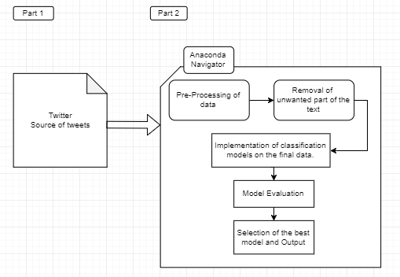
Figure 4: Design Specification

The part 1 in the design specification represents the source of our data. Twitter is the source of data. This is section also includes the conceptual understanding of the research and also the time spent or formulating the research question. The part 2 includes all the processing done on the data. The data is pre-processed which include conversion of JSON files into .csv. Followed by removal of unwanted characters from the textual data. In the end the final form f data is used for model implementation.

Implementation

In this section, the steps after the extraction of tweets from twitter are explained. It starts with dataset preparation and concludes with model implementation. The image displayed below shows the implementation process.

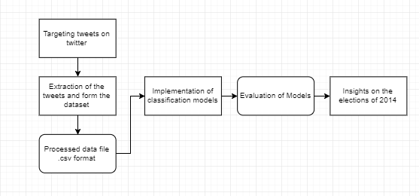
Figure 5: Implementation process flow

Dataset Preparation

User’s raw tweets has many noises and redundant data which are irrelevant for model. Hence, we need to pre-process the data and do the cleaning and wrangling for making tidy and ready for process the tweets for model. In this section, we will explore this in detail.
Pre-Processing is a vital step in the implementation. A clean and pre-processed dataset leads to smooth and efficient model training. If the pre-processing steps are not executed properly, the model trained on such data will yield less accurate results. Our aim is to remove all the hash-tags and other unwanted characters from the text. Feature engineering and target labelling are used as final steps to process the data.

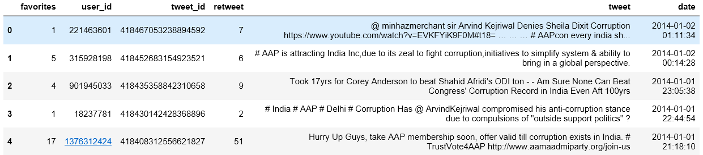
Figure 6: A glimpse of data

Model Implementation
This section shows the proposed model to recognize and classify the tweets into the respective party. Here, we are proposing Naïve Bayes, Random Forest, XGboost and LSTM Neural Network classifier to build the classification model. And implemented Lexicon methodology to analyse the Sentiments of tweets. As this is unsupervised data need to label the data first to make this data to supervised and then given it to input to classifier for fit and train.

Proposed Model

Proposed Model has consisted of below components:
- Dataset Preparation: The first step is the Dataset Preparation step which includes the process of loading a dataset and performing basic pre-processing. The dataset is then split into train and validation sets.
- Target Labelling: After cleaning and wrangling, target label needs to create to make the data to supervised data. HashTag Extraction and Pattern Matching used to identify the target of tweets and label them for further training of data.
- Feature Engineering: The next step is the Feature Engineering in which the raw dataset is transformed into flat features which can be used in a machine learning model. This step also includes the process of creating new features from the existing data.
- Model Training: The final step is the Model Building step in which a machine learning model is trained on a labelled dataset.

Sentiment Analysis

In this section, we will focus on the sentiment which is reflected from the tweets. Visualization tools WordCloud has been used to depict the trending words in the period.
In a WordCloud the word which was the most trending will appear bigger than the less frequent words.

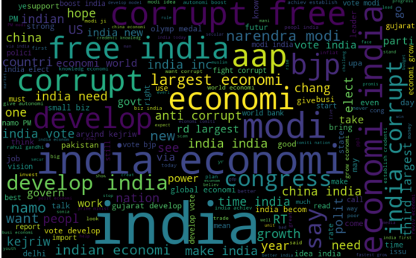
Figure 7: WordCloud

From the above mentioned we could conclude that , BJP along with AAP appeared in most of the tweets. The population is stressing on the words like ‘corrupt’, ‘development’, ‘econmic’.

Using textblob library which is based on the lexicon method to identify the sentiments of tweets and classified to particular party.

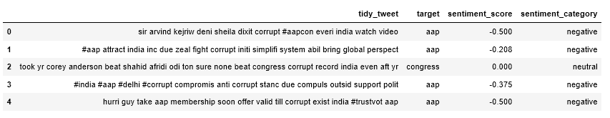
Figure 8: Sentiment analysis

Below graph depicted the sentiments counts of our dataset.
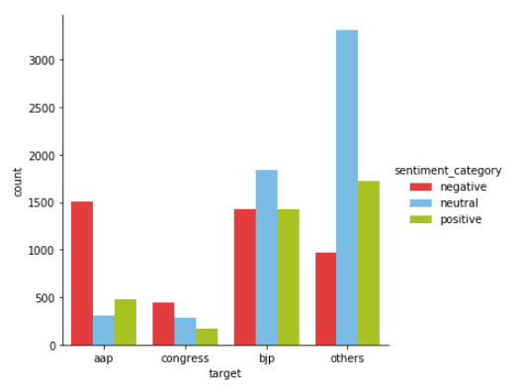
Figure 9: Polarities of the tweets

From the graph displayed above it visible that BJP has more number of tweets. Among which the tweets in favor and tweets in against are almost same. The number of neutral tweets is high. As for AAP, the number of negative tweets are more and same goes for INC(congress). Sentiment analysis on the data shows that BJP was the party with more number of tweets as well as more number of positive tweets. Even though they have equal number of tweets which are negative.

Hashtag and Keyword based Target Labelling

The collected data is unsupervised data. It does not contain the target label, from which the tweets are classified. A manual approach was selected to depict the data. We have selected from target words which were used for each of the political parties.

Target | Hashtag/Keyword
AAP | #aap, #aamadmiparty, #arvind, #kejriwal, #askkejri #askaskmodi, #lokpaal #janlokpal, #jhaadu, aap, arvind, kejriwal, sisodia
BJP | #modi, #namo, #acchedin, #amitshah, #bjp, #chaiwala, #askmodi, #askjaitley, #narendra #modisarkar, #abkibarmodisarkar, narendra modi, namo, bjp
Congress | #congress, #gandhi, #rahul, #pappu, #agustawestland #feku #manmohansingh, inc, upa, rahulgandhi, sonia

Referring the table above, the targets were identified and the data was concatenated in our dataset. After the execution of pre- processing steps we get the following form of data.

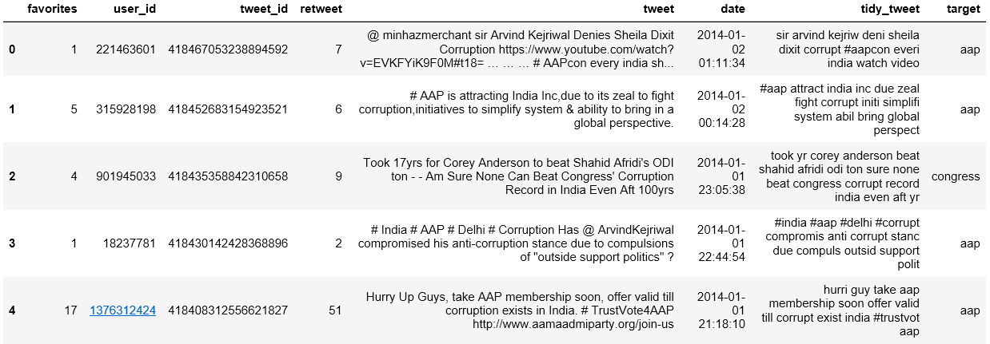
Figure 10: Processed data

Feature Engineering
In the this section, feature vectors and new features are extracted. This step will make the model implementation simple. We made the use of following different ideas in order to obtain relevant features from our dataset.

1.TF-IDF Vectors as features
- Word level
- N-Gram level
- Character level
2.Word Embeddings as features

Exploratory Data Analysis

In view of understanding the data to a better level this section was drafted. In this section we display some of the visualisation which give more clarity to the process. These graphs provide use the basic statistics observed in the elections of 2014.

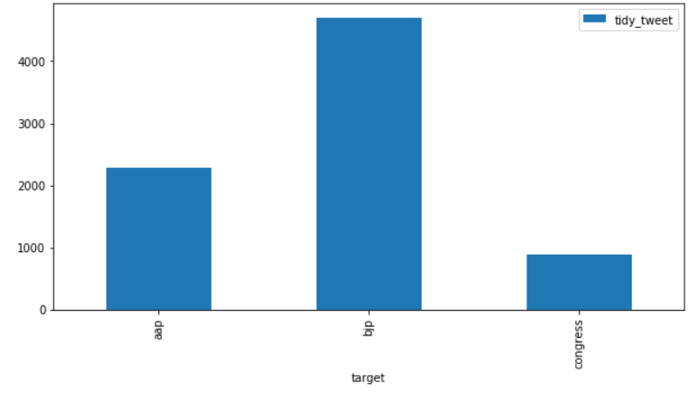
Figure 11: Number of tweets for each party

The above displayed graph shows the number of tweets for ach party. BJP tops with most number of tweets, followed by AAP. The next thing that we wanted to see is, the activities on twitter related to elections from January 2014 to September 2014.

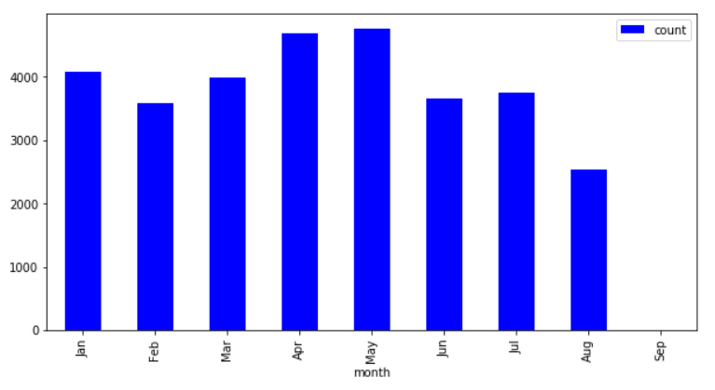
Figure 12: Twitter Activity

From the graph it is visible that the months of April and May observed more number of tweets related to elections. It is because April and May are the months closer to the two largest phases of elctions.

Let us analyse the activity of tweets according to hours in a day.

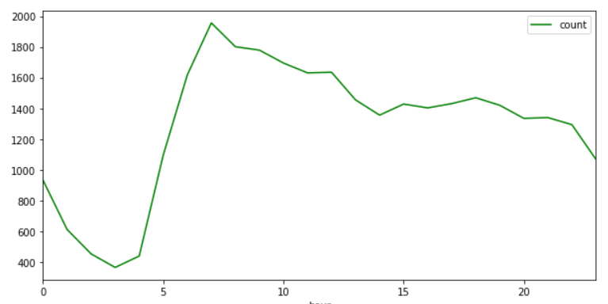
Figure 13: Per Hour activity
It is observed that the hours in the day from 5 am to 10 am the number of tweets keep rising exponentially. While after 10 am the activity of tweets goes down gradually.

Model Implementation and Evaluation

In this section, we will implement the different classifier and evaluate their performance and accuracy and after analysis will implemented the best fit model for this project. To fit and train the model, first split the data in the ration of 80:20 where 80% of data has been split for training and 20% of data for testing.
As the target data is in categorical type hence, encoded into numerical using the LabelEncoder method using Scikit-Learn.

Naïve Bayes Classifier

It is mostly used for classification tasks. This model assumes that the target variable is independent of the presence of other variables
Bayes theorem provides a way of calculating posterior probability P(c|x) from P(c), P(x) and P(x|c). Look at the equation below:
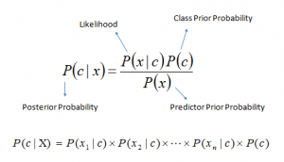
Above,
- P(c|x) is the posterior probability of class (c, target) given predictor (x, attributes).
- P(c) is the prior probability of class.
- P(x|c) is the likelihood which is the probability of predictor given class.
- P(x) is the prior probability of predictor.

It converts a data set into a frequency table

Classification Score & Accuracy:

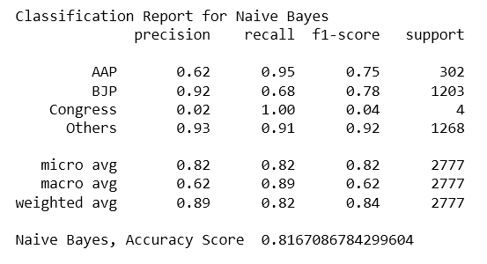
Figure 14: Naïve Bayes output

Random Forest Classifier

Random forest model is one the best models used for the classification tasks. It is termed under ensemble models. It is a member of tree model family.
Classification Score & Accuracy:

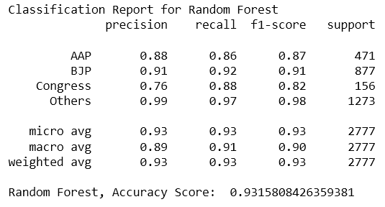
Figure 15: Random Forest Output

XGBoost classifier

It is a supervised machine learning model. It is used reducing bias and variance It boosts the weakest classifier with least covariance and classifies it nearly accurately. It stands for ‘Gradient Boosting’.

Classification Score & Accuracy:

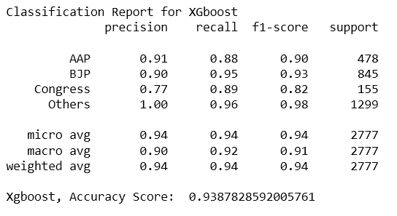
Figure 16: XGBoost output

Recurrent Neural Network – LSTM Classifier

Compared to Feed-forward neutral networks the flow of output from each stage in RNN flows in both direction. This both direction flow of data creates a ‘memory state’. This function is related to the human brain. In RNN (Recurrent Neural Network) the through and flow of data causes problems in preliminary stages. Thus a new type of neural network named as ‘Long Short Term Memory’ models were developed.

Hyperparameters for LSTM Model

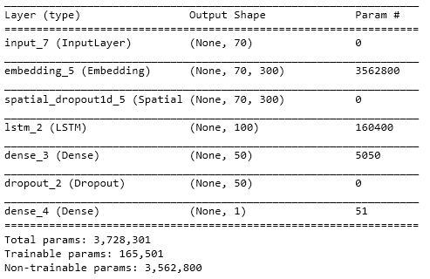
Figure 17: LSTM output

Evaluation and Validation

After implementing above described models, we got to know that LSTM RNN has failed to achieve targeted accuracy and the reason is that size of data is not up to the standard which makes underfit the model. XGboost model outperformed all the other models hence, implemented this in our project and saved the model using JobLib library as ml_clf_model.pkl.

Below depicted the summary of Model and their accuracy:

Model | Accuracy
Naïve Bayes | 0.81
XGboost | 0.94
Random Forest | 0.93
LSTM | 0.65

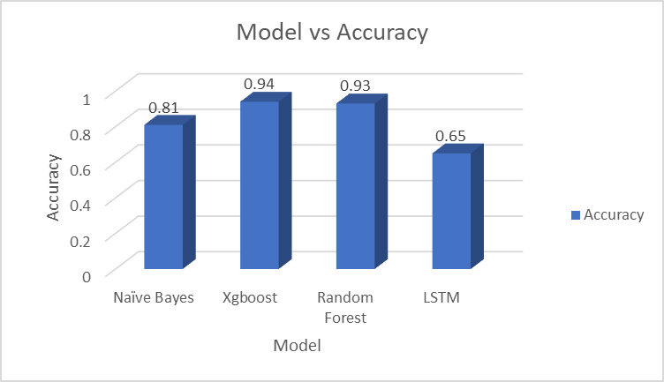
Figure 18: Model Comparison

Hence, after implementing the XGboost model in our project, we have tried to classify the tweet and validate it by giving different types of tweets as input and validate the classified party.

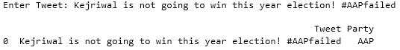
Figure 19: Review for AAP

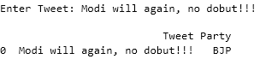
Figure 20: Review of BJP

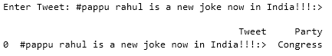
Figure 21: Review of Congress

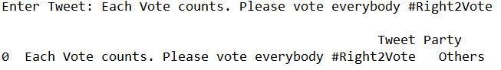
Figure 22: Review for Other smaller parties

Ethics

This research is based on the tweets acquired from twitter. The dataset formed after the process contains the user-IDs of the bloggers. The user-ID are not taken into consideration while analysis. Any form of personal data will be respected and protected. The main goal of this research is to analyse and present the statistics of the Indian elections of 2014. This achieved by documenting an analytical and classification system. In conclusion the data used in this research is completely dedicated for academic purpose.

Conclusion and Future Work

The implementation begins with extraction of tweets from Twitter. The tweets were then downloaded in the system. After some pre-processing steps the final form of data was obtained. The steps include hash-tags removal, target labelling and feature engineering. Only after performing these operations the data became suitable for further implementation. The analysis of the data reveals that ‘Bharatiya Janta Party (BJP)’ and its prime minister candidate had acquired the most response from the people. While the ‘Indian National Congress’ received the least response from the users. The reason behind Narendra Modi’s success was his strong political campaigning which gained a lot of followers. Graphs showing the statistics of elections depict that BJP received most number of tweets. It was the party with more number of positive tweets. April and May months of the year 2014 received most number of tweets. With more number of tweets posted in the morning. In the related works sections we learned that there was more research done on U.S elections. There are only two final candidates in U.S elections where as in our case there are 3 strong candidates. Models like random forest, XGBoost and naïve bayes were previously used by the researches due to the model’s high computational strength and better performance. Four classification models were used from which XGBoost and Random forest models performed with the highest accuracies 94% and 93% respectively. Naïve bayes model performed with an accuracy of 81%. While the use of RNN-LSTM model on our data didn’t go well. This happened due to high data requirements of the model. The results obtained from our implementation points that ‘Bhartiya Janta Party(BJP)’ had a greater chance of winning the elections. While its candidate Narendra Modi has a greater chance of becoming the Prime Minister of India. In future the results and approach of this research show that this technique can be applicable on analysing the elections of 2019.
In the tear 2014, after coming in power, the ‘Bhartiya Janta Party (BJP)’ passed a resolution in which the government of India demonetised the 500 rupees and 1000 rupees notes and replaced them with new series of notes. This resolution came into effect on 8th of November 2016 and was known as the demonetisation in India. The process of replacing the new notes was not executed efficiently. As Indian economy is a cash oriented economy small-scale businesses were tragically affected. Some businesses even stopped functioning. This turmoil was observed all over the country. These events lead to a rise of opposition against the BJP. The recent tweets depict that BJP does not have the same support that it enjoyed in the elections of 2019. The elections of 2019 are underway. In the initial tweets it was observed that ‘Indian National Congress (INC)’ is gaining much support due to the recent events. The BJP claims that the demonetisation process was executed only to target the illegal money gained by the businesses without paying the designated taxes. This proves that tweets from twitter can be analysed to predict the outcome of the Indian Elections. For the 2019 elections there are 900 million registered voters. There are more number of working class individuals in India’s population. For analysis of 2019’s election there will be more number of tweets available. This will provide more data for the analysts to predict the outcomes with greater accuracy.

References

- Pak, A. and Paroubek, P., 2010, May. Twitter as a corpus for sentiment analysis and opinion mining. In LREc (Vol. 10, No. 2010, pp. 1320-1326).

- Agarwal, A., Xie, B., Vovsha, I., Rambow, O. and Passonneau, R., 2011. Sentiment analysis of twitter data. In Proceedings of the Workshop on Language in Social Media (LSM 2011) (pp. 30-38).

- Nakov, P., Ritter, A., Rosenthal, S., Sebastiani, F. and Stoyanov, V., 2016. SemEval-2016 task 4: Sentiment analysis in Twitter. In Proceedings of the 10th international workshop on semantic evaluation (semeval-2016) (pp. 1-18).

- Bollen, J., Mao, H., and Pepe, A. Modeling public mood and emotion: Twitter sentiment and socio-economic phenomena. In ICWSM (2011).

- Wilson, T., Wiebe, J. and Hoffmann, P., 2005. Recognizing contextual polarity in phrase-level sentiment analysis. In Proceedings of Human Language Technology Conference and Conference on Empirical Methods in Natural Language Processing.

- Wang, H., Can, D., Kazemzadeh, A., Bar, F. and Narayanan, S., 2012, July. A system for real-time twitter sentiment analysis of 2012 us presidential election cycle. In Proceedings of the ACL 2012 System Demonstrations (pp. 115-120). Association for Computational Linguistics.

- Tumasjan, A., Sprenger, T.O., Sandner, P.G. and Welpe, I.M., 2010, May. Predicting elections with twitter: What 140 characters reveal about political sentiment. In Fourth international AAAI conference on weblogs and social media.

- Chung, J.E. and Mustafaraj, E., 2011, August. Can collective sentiment expressed on twitter predict political elections?. In Twenty-Fifth AAAI Conference on Artificial Intelligence.

- Bermingham, A. and Smeaton, A., 2011. On using Twitter to monitor political sentiment and predict election results. In Proceedings of the Workshop on Sentiment Analysis where AI meets Psychology (SAAIP 2011) (pp. 2-10).

- Skoric, M., Poor, N., Achananuparp, P., Lim, E.-P., and Jiang, J. Tweets and votes: A study of the 2011 singapore general election. In System Science (HICSS), 2012 45th Hawaii International Conference on (2012), IEEE, pp. 2583–2591.

- Beloglazov, A. and Buyya, R. (2015). Openstack neat: a framework for dynamic and energy-eﬃcient consolidation of virtual machines in openstack clouds, Concurrency and Computation: Practice and Experience 27(5): 1310–1333.

- Golbeck, J., and Hansen, D. Computing political preference among twitter followers. In Proceedings of the SIGCHI Conference on Human Factors in Computing Systems (2011), ACM, pp. 1105–1108.

- Castillo, C., Mendoza, M., and Poblete, B. Information credibility on twitter. In Proceedings of the 20th international conference on World wide web (2011), ACM, pp. 675– 684.

- Mustafaraj, E., Finn, S., Whitlock, C., and Metaxas, P. T. Vocal minority versus silent majority: Discovering the opionions of the long tail. In Privacy, security, risk and trust (passat), 2011 ieee third international conference on and 2011 ieee third international conference on social computing (socialcom) (2011), IEEE, pp. 103–110.

- Conover, M. D., Gonc¸alves, B., Ratkiewicz, J., Flammini, A., and Menczer, F. Predicting the political alignment of twitter users. In Privacy, security, risk and trust (passat), 2011 ieee third international conference on and 2011 ieee third international conference on social computing (socialcom) (2011), IEEE, pp. 192–199.

- Metaxas, P. T., Mustafaraj, E., and Gayo-Avello, D. How (not) to predict elections. In Privacy, security, risk and trust (PASSAT), 2011 IEEE third international conference on and 2011 IEEE third international conference on social computing (SocialCom) (2011), IEEE, pp. 165–171.

- Feng, G. and Buyya, R. (2016). Maximum revenue-oriented resource allocation in cloud, IJGUC 7(1): 12–21.

- Cootes, T.F., Ionita, M.C., Lindner, C. and Sauer, P., 2012, October. Robust and accurate shape model fitting using random forest regression voting. In European Conference on Computer Vision (pp. 278-291). Springer, Berlin, Heidelberg.

- Shah, A.D., Bartlett, J.W., Carpenter, J., Nicholas, O. and Hemingway, H., 2014. Comparison of random forest and parametric imputation models for imputing missing data using MICE: a CALIBER study. American journal of epidemiology, 179(6), pp.764-774.

- Chen, T. and Guestrin, C., 2016, August. Xgboost: A scalable tree boosting system. In Proceedings of the 22nd acm sigkdd international conference on knowledge discovery and data mining (pp. 785-794). ACM.

- Fan, Y., Qian, Y., Xie, F.L. and Soong, F.K., 2014. TTS synthesis with bidirectional LSTM based recurrent neural networks. In Fifteenth Annual Conference of the International Speech Communication Association.

- McCallum, A. and Nigam, K., 1998, July. A comparison of event models for naive bayes text classification. In AAAI-98 workshop on learning for text categorization(Vol. 752, No. 1, pp. 41-48).

https://www.bbc.com/news/world-asia-india-26847432
https://datanin.wordpress.com/2014/05/13/word-clouds-on-few-keywords-of-lok-sabha-election-2014/

